**Register Page**

**Database used: sql lite**

* Used POST method to get input from the users who wants to register to our website

Inputs include First name, Last name, Email, Password, password again. Used csrf token to submit form securely.

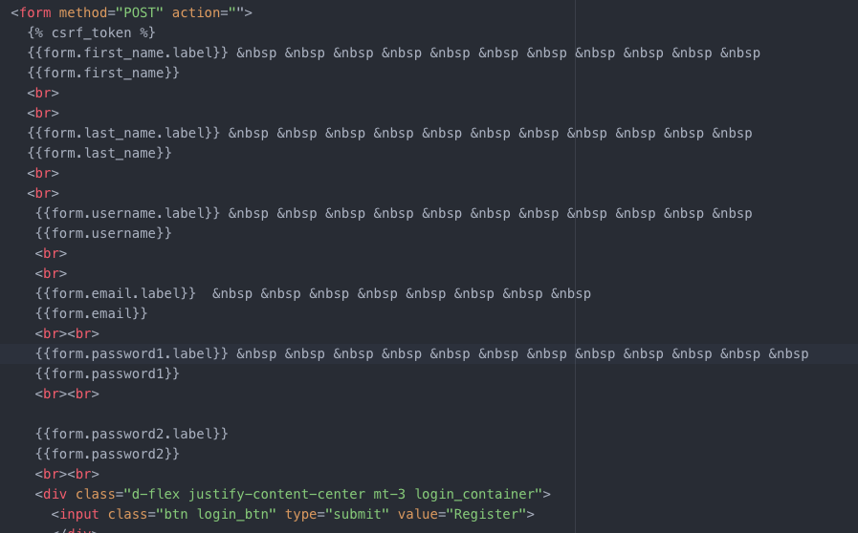

* The inputs obtained are verified in the backend and if all the information is provided, then only the information is stored in the database. Ths code for the verification is written in views.py
* Used django.contrib.auth.forms import UserCreationForm, from django.contribimport messages, from django.contrib.auth import authenticate,login,logout Django modules for registration and authentication.
* Used @login_required decorator for safe logout

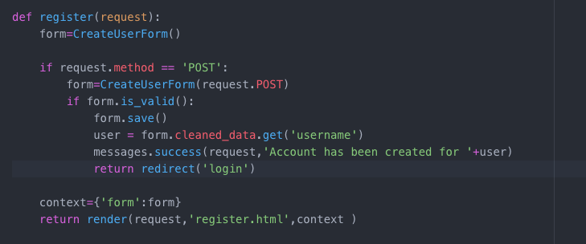

* If any input is not provided the frontend will prompt that particular information is missing.

**Login Page**

* Login page 🡪 User name and password inputs are sent back to backend using POST method.

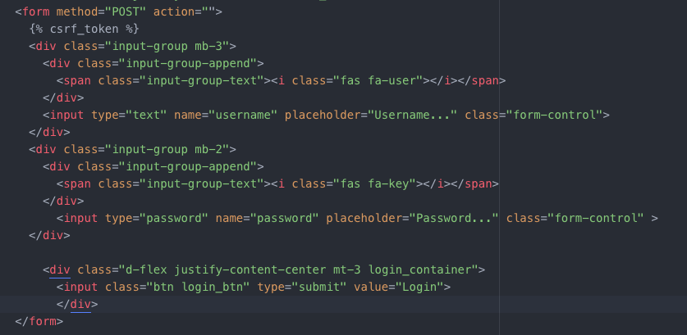

* Validation of user name and password is performed in views.py

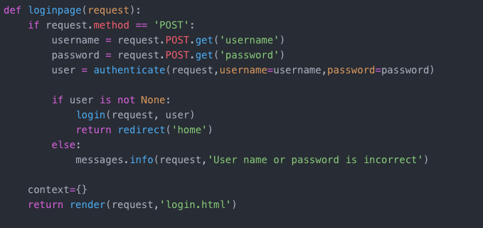

It will check if the user is available in database or not and password matching if the user exists.

If username and password matches it will redirect to home page.

